**GOVERNMENT OF THE REPUBLIC OF MALAWI**

**ROADS AUTHORITY - MALAWI**

**TERMS OF REFERENCE**

**Consultancy Services for Environmental and Social Impact Assessment and Resettlement Action Plan for the Construction of Machinga Weigh Station and Lilongwe Inland Examination Centre**

The Chief Executive Officer

The Roads Authority , Off Paul Kagame Road, Functional Building

Private Bag B346, Lilongwe 3

Malawi

March, 2025

**Table of Contents**

1. Introduction 1

2. Background 2

2.1. Machinga weigh station 2

2.2. Lilongwe Inland examination Centre 3

3. Objective of the Consultancy 3

4. Scope of Services 5

4.1. General 5

4.2. Baseline Studies 5

4.2.1. Environmental components 5

a. Land, Soil and geotechnical 5

b. Water Resources 5

c. Air Quality 6

d. Noise Levels and vibration 6

e. Flora and Fauna 6

4.2.2. Social components 6

4.2.3. Climate and Meteorological Studies 7

5. General Contents of the Plans and Reports 7

5.1. Specific Contents of the ESIA Report 8

6. Public disclosure 9

7. Preparation of Bidding Documents, Bills of Quantities and Cost Estimate 10

7.1. Bidding Documents 10

7.2. Bill of Quantities 10

8. Staff Requirements 10

9. Deliverables, Reporting and payment schedule 14

10. Duration of the assignment 15

11. Facilities to be provided by the Client. 15

12. Facilities to be provided by the Consultant 16

Annex 1: ToRs from MEPA 17

# Introduction

The Governments of Malawi and Mozambique have obtained a credit and grant from the International Development Association (IDA) under the Southern African Connectivity and Trade Project (SATCP), P164847. The project development objective is to reduce trade costs and time, improve access to infrastructure, and increase value chain development in targeted corridors of Malawi and Mozambique. Reducing trade costs and improving the road network will facilitate the development of trade by improving access to global and regional markets. There is substantial economic potential for increasing regional trade, especially regarding agribusiness, light manufacturing, and services including logistics and tourism and attracting private investment in these sectors.

The main project components are:

* Component 1: Reducing trade costs through trade facilitation, including border infrastructure and regulatory framework reforms.
* Component 2: Strengthening regional coordination and supporting Project implementation.
* Component 3: Increasing investment in regional value chains; and
* Component 4: Improving the transport infrastructure of market access.

Under component 1, the project will construct the Lilongwe Inland Examination Centre. An IEC is a legally established Customs and border agency examination facility that enables to open, unpack, mark, weigh, unload any container or goods presented for import or export, at a designated location away from the prescribed land borders and airports. The Lilongwe Inland Examination Centre will be situated in Lilongwe City at Lilongwe within land allocated by the Ministry of Lands from the Agricultural Research and Extension Trust (ARET) along the M12 off Mchinji Round about.

Under Component 4, which aims to improve road safety along the corridors, the project will finance the construction of a semi-permanent weighbridge station along the Liwonde – Matawale road at Machinga. The weigh station will be constructed to screen goods vehicles with regards to overloading.

It is against this background that the Government of Malawi through the Roads Authority want to engage a suitable consultant to carry Environmental and Social Impact Assessment (ESIA) and develop a Resettlement Action Plan (RAP) for the construction of a weigh station at Machinga along Liwonde – Matawale Road and a Lilongwe Inland Examination Centre along Mchinji-Lilongwe Road.

# Background

## Machinga weigh station

SATCP intends to construct a weigh station along Liwonde –Matawale Road in Machinga District. The weigh station will have a weigh bridge, offices, staff housing, access road diversions and other associated infrastructure. Currently, procurement of a separate technical consultancy for architectural and engineering design services to design the stated facilities is underway. During design of the weigh station facilities, this consultancy services will develop ESIA and RAP based on the draft and final detailed designs developed by the technical consultant. An ESIA will be developed based on the terms of reference provided by the Malawi Environment Protection Authority as provided under annex 1 and as per terms of references specified in this document. Figure 1 shows proposed location of Machinga Weigh-station indicated as a yellow polygon.

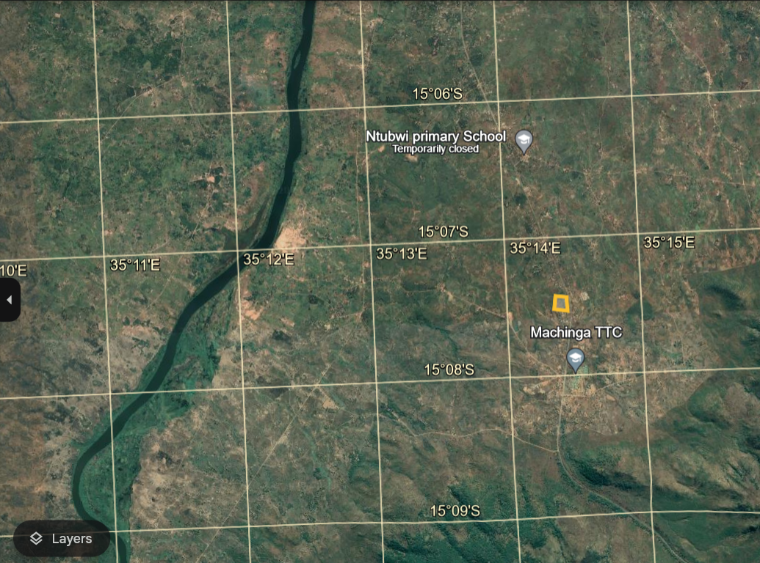

Figure 2‑1 Location of Machinga Weigh Station

## Lilongwe Inland examination Centre

SATCP intends to construct a Lilongwe Iland Examination Centre in Lilongwe City next to ARET and MRA inland port along the Lilongwe – Mchinji M012 Road in the City of Lilongwe. The construction of Lilongwe Inland Examination Centre is expected to bring efficiency in terms of inspection of containerized imports as inspection will be done inland. The land is fully owned by MRA and has been obtained from part of the land owned by Agricultural Research and Extension Trust (ARET).

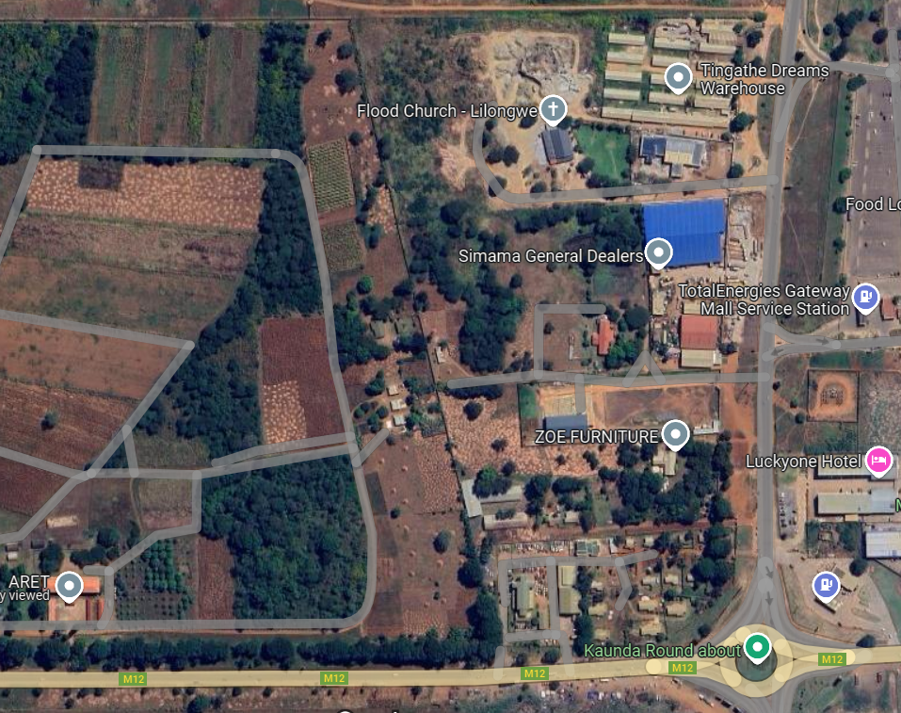

Figure 2‑2 Location of the Project Area along M012 Road in Lilongwe City

# Objective of the Consultancy

The main objectives of these consultancy services are;

1. Carry out a preliminary Environmental and Social Impact Assessments for Machinga weigh station and Lilongwe Inland examination Centre:
2. Carry out baseline surveys on biophysical and social economic parameters namely, Air quality, noise and vibrations, water quality, geological formation, climate change, climatic conditions, hydrology, etc) biological and socio-economic baseline conditions.
3. Review the Engineering Design and ensure that all recommended environmental, social, health and safety considerations have been incorporated in the designs e.g. climate resilience designs, environmental and social sustainability
4. Ensure that design changes have been affected upon having a joint agreement with RA, Design Engineer, Stakeholders and the independent consultant.
5. Develop Traffic Safety Management Plan (TSPM) alongside with the ESIA report.
6. Develop a guide for Waste Management Plan, Camp Site Management Plan, Hazardous Substances Management Plan, Noise and Vibrations Management Plan, Hazardous Waste Management Plan (including asbestos if identified), Emergency Response Management Plan, Air Quality Management Plan, Storm Water and Drinking Water Management Plan for construction phase (which will be developed in detail by the contractor).
7. Provide cost estimates for implementation of Environmental and Social Management Plans and monitoring plans for the weigh station and Lilongwe IEC and ensure that these have been factored into the respective bills of quantities for the bidding documents.
8. Facilitate public disclosure of the safeguard’s instruments upon the approval by MEPA and the World Bank
9. Assess and ensure that the E&S instruments prepared (i.e. ESIA, ESMP and RAP) are in line with the Malawi regulatory and legal framework and per er following triggered World Banks OPs;

Table 3‑1 World Bank Safeguard Policies

|  |  |
| --- | --- |
| **Environmental Policies**  OP/BP 4.01 Environmental Assessment  Ensures projects are environmentally sound and sustainable.  OP/BP 4.09 Pest Management  Focuses on the procurement and use of pesticides in projects.  **OP 4.11 Physical Cultural Resources** Aims to protect cultural heritage in project areas. | **Social Policies**  OP/BP 4.12 Involuntary Resettlement  Addresses the impact on people displaced by projects. |
|  |
| **World Bank Additional Safeguard Instruments** | |
| - Environmental, Health and Safety Guidelines  - Environmental Assessment Sourcebook (and updates) | - WB Participation Sourcebook (1996)  - Disclosure Handbook  - Electronic Resettlement Guidebook |

Source: World Bank, Safeguard Policies.

# Scope of Services

## General

The scope of the assignment includes preparation of Environmental and Social Impact Assessment, Environmental and Social Management Plan and Resettlement Action Plan for the proposed Machinga Weighbridge and Lilongwe Inland Examination Centre. These instruments will be prepared in accordance with national legislation and policies and the Environmental and Social Management Framework/Resettlement[1] Policy Framework for the project. The Consultant shall take into consideration the World Bank OPs in the preparation of the ESIA.

The consultant shall ensure that the ESIA, EMSP and RAP report cover all environmental, social, health and safety requirements, including all baseline studies, and feasible and sustainable mitigation and enhancement measures for the identified impacts.

## Baseline Studies

At minimum, the consultant shall carry out site-specific baseline studies as outlined in the following sections:

### Environmental components

1. **Land, Soil and geotechnical**

* **Land Use and Land Cover Mapping:** Determine the current use of land and the types of vegetation cover.
* **Soil Quality Assessment:** Analyze soil characteristics, including texture.
* Geotechnical assessment

1. **Water Resources**

* **Surface Water Quality:** Test for physical, chemical, and biological parameters in nearby rivers, or streams.
* **Groundwater Quality:** Assess the quality of groundwater sources in the area, and monitoring around the site and nearby boreholes which the communities are using.
* **Hydrology:** Study the water flow patterns, drainage, and potential flood risks.

1. **Air Quality**

* **Air Quality Monitoring:** Measure levels of pollutants such as PM10, PM2.5, NOx, SOx, and CO.

1. **Noise Levels and vibration**

* **Ambient Noise Survey:** Measure existing noise levels during different times of the day and night.

1. **Flora and Fauna**

* **Biodiversity Assessment:** Document the presence of local flora and fauna, including any endangered or protected species, migration routes of animals
* **Habitat Survey:** Identify and map critical habitats and ecosystems.

### Social components

This should also cover analysis of social issues in relation to the project.

1. **Demographics**

* **Population Profile:** Collect data on the population size, age distribution, gender ratio, and ethnic composition of nearby communities.
* Assessment of issues and vulnerability of certain groups

1. **Socio-economic Conditions**

* Economic and livelihood Activities: Identify main economic activities, employment rates, and sources of income.
* Labour conditions; Status of availability of labour
* Infrastructure and Services: Assess the availability and quality of infrastructure such as roads, healthcare, education, and water supply.
* Housing and household composition

1. **Land Ownership and Use**

* **Land Tenure Systems:** Understand the local land ownership patterns and any land use conflicts.
* **Cultural and Historical Sites:** Identify any culturally or historically significant sites **that** may be affected by the project.
* Land inventory

1. **Community Health and Safety**

* **Health Baseline:** Gather information on the prevalent health issues, healthcare facilities, and access to medical services.
* **Safety and Security:** Assess current safety and security conditions in the area.
* Evaluate impact of standing/waiting trucks along roadside – traffic safety, community safety, and impact (social and environmental)
* Consider potential spills from the transport vehicles, especially of hazardous substances and where/how this would impact the environment and community.

1. **Vulnerability based on age, socio-economic, gender and other aspects**

### Climate and Meteorological Studies

* **Climate Conditions:** Document the climate patterns, including temperature, precipitation, wind patterns, and seasonal variations.
* **Meteorological Data:** Collect data from weather stations or historical climate data relevant to the project area.

The costs of carrying out these studies (including consultations and stakeholder engagement) shall be included under this scope of assignment. The consultant shall be expected to analyze the identified impacts, and as much as possible, propose mitigation and enhancement measures, taking into consideration the mitigation hierarchy, of which some will provide a recommendation to the design engineer to effect changes in the designs of the infrastructures.

For the Resettlement Action Plan (RAP), the consultant is expected to carry out a census of all Project Affected Persons (PAPs). As much as possible, the consultant shall provide a design that considers identified impacts and propose other measures impacts in the ESIA/ESMP and RAP to minimize the number of PAPs.

The consultant shall develop ESIA, RAP and the ESMP which will submitted to Roads Authority (RA) following a thorough public consultation with interested and affected parties. RA will be responsible for facilitating clearance of the reports by the World Bank and issuance of the environmental permit by MEPA.

# General Contents of the Plans and Reports

The ESIA, RAP and ESMP shall contain the following but not limited to:

* 1. Description of the biophysical environment and the environmental and socio-economic situation in the project area, which represent the baseline of the Project.
  2. Provision of description and updated baseline data for the social environment, including existing data regarding GBV/SEA/SH access and functionality of and the available GBV/SEA Referral Pathways (GBV response services).
  3. Description of project alternatives, especially those which are significantly different from an environment perspective (e.g. location alternatives affecting different ecosystems or construction technology and material, design etc..
  4. The policy, legal and institutional framework for environmental and social management and assessment of impacts relevant to the nature of the project.
  5. Identification, evaluation, and measurement of the extent of positive and negative impacts and direct and indirect environmental risks in the Project's areas of intervention during the construction, operation, maintenance and decommissioning of the infrastructure
  6. Description of the mechanism and institutional arrangements for the implementation of the ESIA, RAP and preparation of the ESMPs, specifying the roles and responsibilities of the agencies and all actors (central, regional/local, municipal and village) involved in the implementation;
  7. Evaluation of the capacities of the governmental and local implementing agencies involved in the implementation of the ESIA and sensitization on the environmental and social issues of the project and propose appropriate measures for sensitization, institutional strengthening and/or technical capacity building of the various actors. The ESIA will need to come up with the stakeholder engagement plan to include the mentioned elements;
  8. Description of the monitoring and evaluation mechanism to ensure systematic and effective monitoring of the main ESIA recommendations.
  9. RAP report that contains as an annex property census and land inventory that is done in line with the WB’s involuntary resettlement policies and Malawi Government’s policies.
  10. Carry out stakeholder engagement and public consultations during the studies as per stakeholder engagement plan developed;
  11. Assessment of local capacity and practices in managing grievances and establishing these structures in project area
  12. Incorporation of GBV/SEA/SH issues in the development of project instruments particularly inclusion of a GRM that is GBV/SEA/SH responsive and mitigation measures should include a referral path and a code of conduct that is SEA/SH responsive.

## Specific Contents of the ESIA Report

The contents of the ESIA report shall, as a minimum, comprise the following;

1. Provide a clear project description which shall have a brief description of the project, location map of the project area (including access points), project area, political and administrative location, technical justification for the project, alternative analysis, estimates project area, activities to be done under each phase of the project and timelines, flow chart of project activities under each phase, list of machinery to be used, routes of transportation of materials versus traffic management, water supply details (amount of water used (m3 per day), average flow rate), energy provision details (kWh per day or month), drainage of waste water and storm water, access routes, labor requirements, work camps (where applicable), siting of the work camps criteria, sources of raw materials (sand, gravel sites and quarry sites) to be used, inventory of anticipated chemical , toxic or hazardous substances, handling and disposal of waste (solid, liquid and gaseous waste)
2. Describe legislation (regional, national, and municipal) and WB OPs that was considered in the development of the project or applied according to the projects.
3. Provide a description of the physical environment focusing on regional geological aspects, local geological aspects, geotechnical characteristics, geological setup of the area, geomorphological characteristics of the study areas, soils, climate, hydrology, surface and groundwater, water quality, water flow of the rivers surrounding, flood levels, current heat waves, vulnerability to contamination of ground water, air quality, noise and vibrations, odors, radiation sources available, natural threats e.g. seismic threats, mass movements, floods, and others.
4. Provide a description of biological environments focusing on flora and fauna (IUCN red listed species) ,
5. Provide a description of social economic and cultural environment focusing on characteristics of the population, road safety and traffic flow, emergency services, basic services (e.g. potable water, sewage, drainage, electricity, public transport, garbage collection, schools, hospitals, clinics and others), local perception of the project, potential conflicts due to the project, perception and attitudes of the communities), communicable infrastructure (roads, schools, health, parks, historical sites), displacement and movement of communities, status of Gender based violence, sexual exploitation and abuse, child labour, trafficking in persons, description of cultural environment, historical, archeological and paleontological and religious value). Landscape, socially sensitive and vulnerable areas.
6. Identify and analyze environmental and social impacts of the projects, develop the environmental and social management plan and monitoring plan which shall also include the closure plan for the construction works.

All documents to be submitted to the RA must comply with the environmental and social management tools established in the Project. Before submission of the documents for clearance by World Bank. the Consultant shall share them with the RA for review and clearance. The report shall be approved by Malawi Environment Protection Authority (MEPA). Note that the consultant shall be required to address comments from RA, the World Bank and MEPA.

# Public disclosure

The consultant in collaboration with RA shall carry out public disclosures on various platforms with consideration of local context for the results of the ESIA, ESMP, and RAP. The first local disclosure shall be done before the approval of the report to ensure that the missing information is included before the reports have been approved and implemented. The final disclosure shall be after the approval of the report to notify the public that their concerns and inputs have been considered in the study. The costs of public disclosure shall be borne by the client (RA).

# Preparation of Bidding Documents, Bills of Quantities and Cost Estimate

## Bidding Documents

The bidding document shall be prepared fully in accordance with the latest World Bank Standard Procurement Documents. The consultant shall prepare adequate technical specifications and incorporate itemized Environmental, Social, Health and Safety considerations in the bidding document based on the summarized ESMP developed within the ESIA.

## Bill of Quantities

Calculated quantities for the items of work to be executed shall be based on the finalized E&S requirements for the project and these shall include the itemized Environmental, Social, Health and Safety considerations.

# Staff Requirements

Table 2 below shows the Key Staff Time Input (development of ESIA, ESMP and RAP and bills of quantities for implementation of ESIA, ESMP and RAP requirements).

Table 8‑1 Staff man-months

|  |  |  |  |
| --- | --- | --- | --- |
| **Key Professional Staff** | | **Man-Months required (Machinga Weigh station)** | **Man-Months required (Lilongwe IEC)** |
| 1 | Team Leader (Environmental and Social Impact Assessment Expert) | 4 | 4 |
| 2 | Social and GBV Expert | 4 | 3 |
| 3 | Traffic Management and Road Safety Expert | 2 | 2 |
| 4 | Registered Land Valuer | 2 | 2 |
| 5 | Ecologist Specialist (2) (Zoology or Botany) | 2x2 | 1x2 |
| 6 | Physical planner | 1 | 2 |
|  | **Non-Key staff** |  |  |
| 7 | Climate Change Expert | 2 | 1 |
| 8 | Hydrologist | 2 | 1 |
| 8 | Hazardous Substances Management Specialist | 2 | 2 |
| 9 | Architect | 1 | 1 |
| 10 | Health and Safety Expert | 2 | 2 |
|  | TOTAL estimated Man– Months | 26 | 22 |

The assignment shall be carried out under a lump sum contract based on the key deliverables. The effort of key-experts time input for the assignment is estimated at 26 person months for weigh station and 22 person months for the inland examination centre. The Consultant should make his assessment of the staffing inputs required to carry out the tasks for this part of the assignment however, as a minimum, the Consultant should maintain the key expert staff positions outlined in the table. Only the CVs of these key experts will be evaluated. Other non-key experts may be added but their CVs will not be evaluated.

The minimum qualification general and specific work experience of the staff is presented in the table 8-2 below, which will form the basis of the technical evaluation.

Table 8‑2 Minimum qualification requirements

|  |  |
| --- | --- |
| **Team Leader** | |
| **Environmental and Social Impact Assessment Specialist** | |
| Minimum Qualification | She/he shall have a minimum master’s degree Environmental Sciences or related field. He/she should be registered with the appropriate professional registration institution. |
| Responsibilities | Lead ESIA study |
| General Work Experience | Minimum of 10 years’ participation in ESIA and ESMP preparation for infrastructure development projects in sub-Sahara Africa in compliance with World Bank or similar international performance standards. |
| Specific Work Experience | Substantial experience in carrying out ESIA studies and preparation of ESIA reports, ESMPs and related management plans. Experience in preparation for safeguard studies for World Bank funded projects.  Team leader for ESIA and ESMP preparation for at least three infrastructure projects in the SADC region in compliance with World Bank standards or similar requirements. |
| Language | Shall be fluent in written and spoken English |
| Role | Lead in development of the ESIA Report |
| **Social and GBV Expert** | |
| Minimum Qualification | She/he shall have a minimum master’s degree in social sciences, development studies or related field |
| Responsibilities | Lead the Development of RAP and socio-economic assessment and social impacts of the project in the ESIA |
| General Work Experience | She/he shall have 10 years of experience in development of ESIAs, RAPs and GBV assessments |
| Specific Work Experience | Knowledge of Laws and regulations related to ESIAs, RAPs and GBV as well as preparation and implementation of Stakeholder Engagement Plan, Grievance Redress Mechanism, Labor Management Plan, and related social safeguards tools |
| Language | Shall be fluent in written and spoken English |
| Role | Lead in Development of RAP report |
| **Traffic Management and Road Safety Expert** | |
| Minimum Qualification | Should have a minimum of a MSc in Civil (highway) engineering/Physical Planning or any related field |
| Responsibilities | Assess road safety risks and propose interventions as well as lead in development of Traffic Management Plans for Construction |
| General Work Experience | At least 8 years in traffic management engineering/planning and designing traffic solutions for a large road construction project |
| Specific Work Experience | Experience in managing at least two road related projects where s/he designed and monitored implementation of traffic management measures and controls |
| Language | Shall be fluent in written and spoken English |
| **Registered Land Valuer** | |
| Minimum Qualification | She/he shall have a minimum a Degree in Land Management, He/she should be registered with the appropriate professional registration institution. |
| Responsibilities | Lead land valuation in conjunction with the social specialist and environmental specialist |
| General Work Experience | She/he shall have 8 years of experience in dealing with land valuation and development of RAPs |
| Specific Work Experience | Knowledge of RAPs in Malawi will have added advantage |
| Language | Shall be fluent in written and spoken English |
| **Ecologist Specialist (2 one for Ecology and other for Botany)** | |
| Qualifications | Degree in Ecology, Botany, Zoology, or related field |
| Specific Work Experience | 7 years of work-related experience, in carrying out biodiversity studies. |
| Competence | Demonstrated competence in carrying out biodiversity studies |
| Language | Shall be fluent in written and spoken English |
| **Climate Change Expert** | |
| Qualifications | MSc in Climate Change, or Environmental Science, Atmospheric Sciences, or related field |
| Specific Work Experience | 5 years of work-related experience, in carrying out Climate Risk assessments or modelling |
| Competence | Demonstrated competence in carrying out Climate Risk Assessment |
| Language | Shall be fluent in written and spoken English |
| **Hydrologist** | |
| Qualifications | MSc in Hydrology or related field |
| Specific Work Experience | 5 years of work-related experience, in carrying out Hydrological Assessment |
| Competence | Demonstrated competence in carrying out Hydrological assessments |
| Language | Shall be fluent in written and spoken English |
| **Hazardous Substances Management Specialist** | |
| Minimum Qualification | Should have a minimum of a MSc in Civil or Chemical engineering or any related field |
| Responsibilities | Assess and compile management plan and necessary permits for the use, storage, handling, management, transport, and disposal of hazardous substances throughout project life including mobilisation activities, renovation activities, construction activities, and operation of the sites, including emergency procedures and spill containment |
| General Work Experience | At least 10 years in hazardous substances management |
| Specific Work Experience | Experience in managing at least two road/border related projects where s/he designed and monitored implementation of hazardous substances |
| Language | Shall be fluent in written and spoken English |
| **Architect** | |
| Minimum Qualification | A registered Architect with a professional body with a minimum of BSc in Architecture with 5 years’ work experience. |
| Responsibilities | Review the designs and interpret the existing designs’ implications regarding E&S. Based on the E&S review align the designs and the E&S input or vice versa |
| General Work Experience | At least 5 years of extensive related to construction and designing of infrastructures |
| Specific Work Experience | 5-year experience in designing and implementation of different types of infrastructure projects including road projects. Experience with conducting stakeholder consultations in support of engineering decision-making. |
| Language | Shall be fluent in written and spoken English |
| **Physical Planner** | |
| Minimum Qualification | MSc in Physical Planning, Civil Engineering or related field |
| Responsibilities | Review the designs and interpret the existing designs’ implications regarding E&S. Based on the E&S review align the designs and the E&S input or vice versa |
| General Work Experience | At least 5 years of extensive related to construction and designing of infrastructures |
| Specific Work Experience | 5-year experience in designing and implementation of different types of infrastructure projects including buildings or roads projects. Experience with conducting stakeholder consultations in support of engineering decision-making. |
| Language | Shall be fluent in written and spoken English |

# Deliverables, Reporting and payment schedule

The Consultant shall prepare and submit the following reports and documents, in English, in an approved format to the Client. The comments of the Client shall be incorporated in the final version of the reports and documentation. The Consultant shall also submit to the client Ten (10) hard copies and one (1) soft copy of each of the reports (which shall be reviewed and approved Malawi Environment Protection Authority (MEPA). The consultant shall also review, and address comments provided by RA and World Bank. The consultant shall be expected to review and address comments from client, World Bank and MEPA. This shall be reflected in the financial proposal of the project. The consultant shall be required to cost the two assignments independently and each shall follow the payment schedule as provided in table 9-1. Table 9-1 below shows the key deliverables and proposed payment schedule for the assignment.

Table 9‑1 Deliverables and payment schedule

| **Deliverable** | **Summary of Contents** | **Submission Time** | **Payment schedule** |
| --- | --- | --- | --- |
| Inception report (combined for two assignments) | * Confirmation of scope of assignment * Mobilisation of key staff * Updated Work plan * Stakeholder engagement plan | One month from the commencement date of the assignment | 25% |
| Draft ESIA for Machinga Weigh station, Draft ESMP for Lilongwe IEC and Draft RAP Machinga Weigh station, Draft ARAP for Lilongwe IEC | * Draft ESIA for Machinga Weigh station, Draft ESMP for Lilongwe IEC and Draft RAP Machinga Weigh station, Draft ARAP for Lilongwe IEC | Three months from the commencement date of the assignment | 30% |
| Final approved RAPs, ESMP and ESIA Reports (independent of each) | * Final Approved ESIA report, RAP and Traffic Management Plan | Four months from the commencement date of the assignment | 35% |
| Bills of quantifies to feed into the bidding documents | * Final Bill of Quantities and Confidential Cost Estimate | Four months from the commencement date of the assignment | 10% |

# Duration of the assignment

The duration of the assignment is four calendar months for the weigh station and three calendar months for the Lilongwe Inland examination Centre.

# Facilities to be provided by the Client.

**• Liaison Officer**

The Environmental Safeguards Specialist in liaison with the Social Safeguards Specialist will be the liaison officer for the assignment and all the information, guidance and assistance will be addressed to the personnel. All reasonable assistance will be provided, including liaison with other Government departments and access to any relevant data that is not classified as restricted. Other personnel provided will be as agreed during the contract negotiations.

**• Other support**

RA shall provide the Consultant, without charge, the following support.

Assistance in obtaining required customs clearances, visas and any other official permits required for the services, as may reasonably be required and the Consultant shall bear the costs;

Other support as may reasonably be needed for the expeditious performance of the required services.

The Client shall provide the Consultant, upon request, with all information relevant to the assignment, which is available to it, and not covered by any confidentiality agreements and will fully cooperate with the Consultant in order to achieve the best results.

The Client shall facilitate introductions to other Departments, Ministries and organizations, with whom the Consultant needs to liaise or co-ordinate activities.

The Client shall facilitate for the Consultant’s personnel in the obtainment of work permits documents where necessary. The Consultant shall bear the cost of obtaining licenses and work permits.

# Facilities to be provided by the Consultant

* **General**

The Consultant shall perform the services specified in the “Terms of Reference” under “Scope of Services,” and shall provide the personnel listed under, "Consultant Personnel," to perform the Services. The Consultant shall submit to the Client the reports in the form and within the agreed periods specified under "Consultant's Reports and Documentation."

* **Accommodation**

The Consultant will be responsible for the provision of accommodation and all related services for his personnel for the duration of the assignment.

* **Computers**

The Consultant will be responsible for his own requirement for computer equipment.

* **Transport**

The Consultant will be responsible for the provision of transport for his personnel.

* **Office** **Facilities**

The consultant will provide office space, secretarial input, telephone and fax, photocopiers, and general office requirements

# Annex 1: ToRs from MEPA

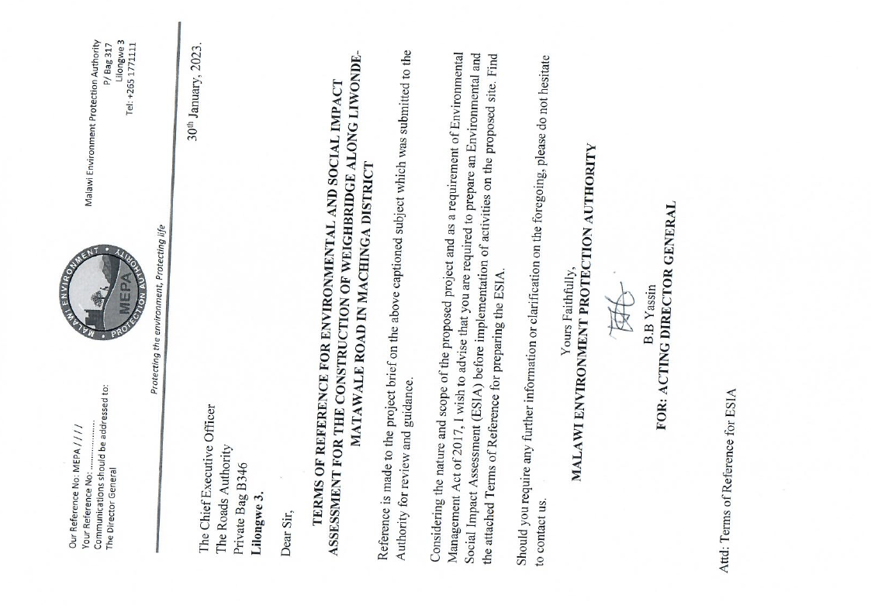

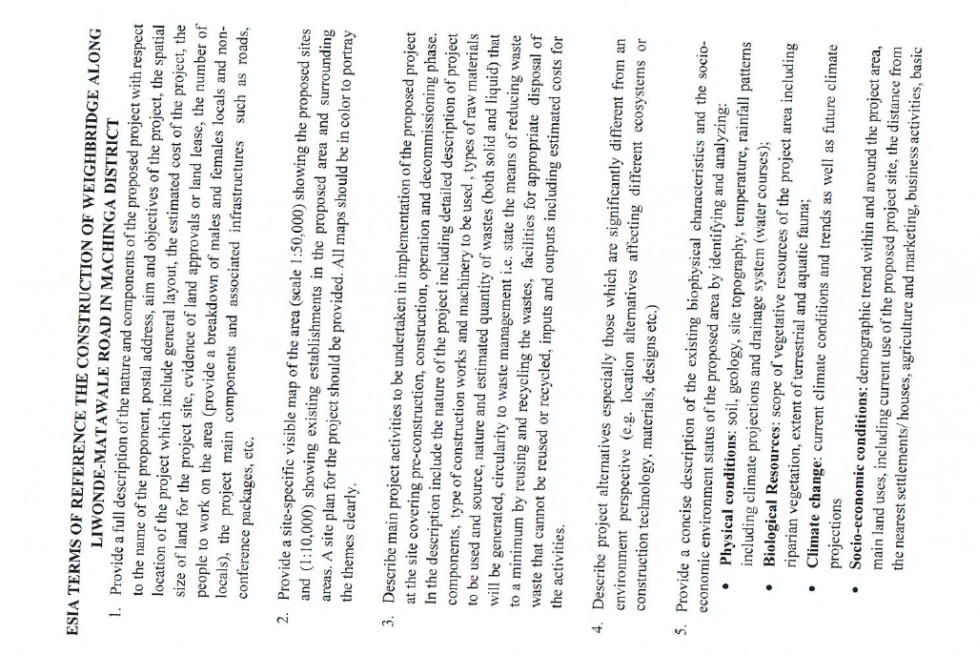

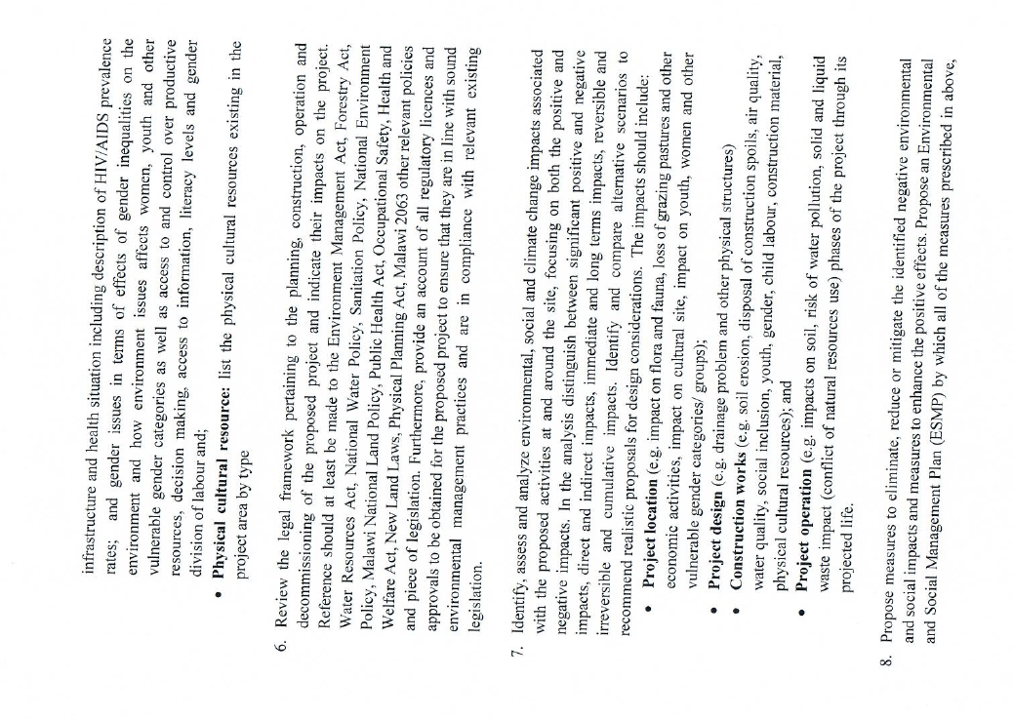

1. An overarching Environmental Social Management Framework (ESMF) has been prepared for SATCP with clear recommendations for the environmental and social impacts of such works. In addition, a Resettlement Policy Framework (RPF) has also been prepared. The RPF and ESMF specifies that the project specific E&S instruments shall be developed based on the terms of references to be provided by the Malawi Environmental Protection Authority (MEPA) which shall also be in line with the World Bank safeguards requirements